# Accessibility Research

## Colour Blindness

Not everyone has perfect vision, around 1 in 12 men and 1 in 200 women worldwide have some form of colour blindness. As a result, it is key to add colour blind options. There is more than one variation of colour blindness so multiple ones will be added. An example of the change of colours seen by a colour blind person is shown below.

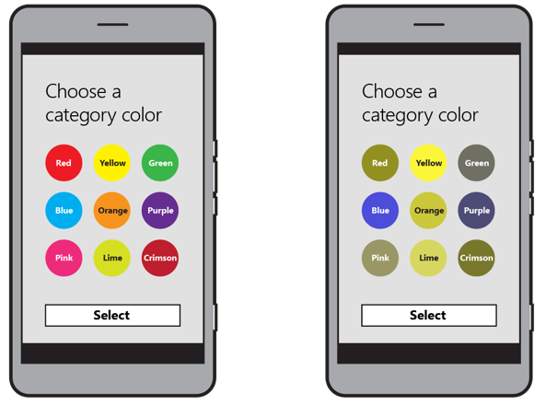

The most common type of colour blindness is red-green. All types are shown below

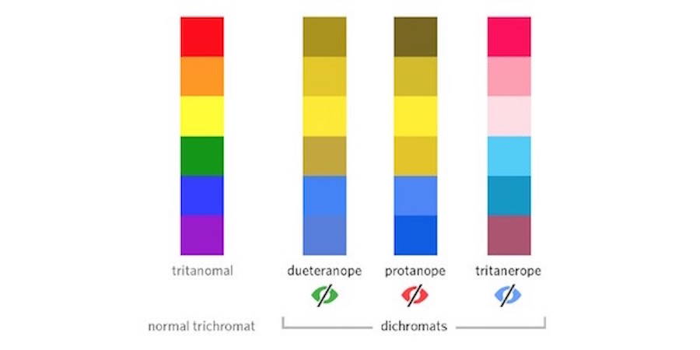

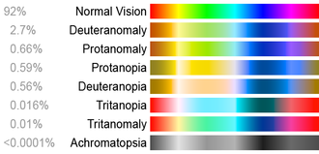

### How to design with colour blindness in mind

* Use colours and symbols, don’t just rely on colour to convey information. Similarly, use patterns and textures to show contrast between elements not just a change in colour.
* Limit the colour palette, less colours causes less confusion.
* Avoid certain colour combinations. These are potential bad ones:
  + Green & Red
  + Green & Brown
  + Blue & Purple
  + Green & Blue
  + Light Green & Yellow
  + Blue & Grey
  + Green & Grey
  + Green & Black

## Talk back

Talk back is a default feature which is incorporated into android. This allows those who are nearly blind to still use their phones. Various ideas have been created within the team on whether or not to incorporate it. However, due to it being a default feature in android, the implementation should be relatively straight forward.

## Audio guide

An audio guide is something which is used for directions. This can be enabled once a navigation section has started. Audio guides are very helpful when navigating due to the fact the user won’t have to look at their phone when navigating, but rather listen.

## Visual Impairment

Minor issues with vision can generally be combatted by increasing the text size. On android devices apps can check if the “Large Text” option accessibility is enabled using

Configuration c = getResources().getConfiguration();

float scale = c.fontScale;

if (scale > 1) {

// large text

}

This can then be used to adjust the font size used in the application accordingly.

## Sources

https://blogs.windows.com/buildingapps/2016/09/13/accessibility-and-your-app-design/

https://usabilla.com/blog/how-to-design-for-color-blindness/

https://www.microassist.com/digital-accessibility/mobile-application-accessibility- part-2-of-2/

https://stackoverflow.com/questions/11826563/detect-if-large-text-accessibility-option-is-enabled-on-android